Tuesday, 8 September 2026, postcard

Yet more portraits (and The Portrait), Louie, and Matilda.

Today, David says he finally feels like himself, though he's still not sure whether it was food poisoning or the heavier-than-usual beers that did his stomach in. But he claims his fundamental error was agreeing to get up for breakfast the first morning we were here. He should have slept in.

This morning, it actually rained lightly, with falling drops and everything.
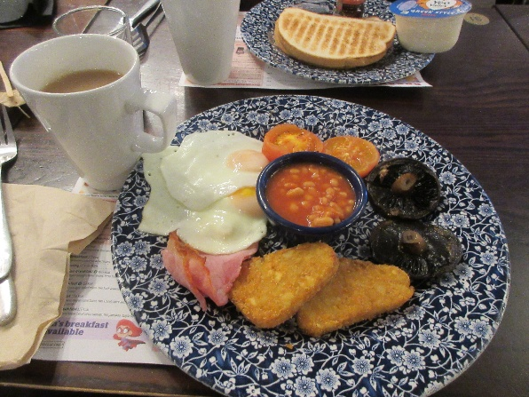
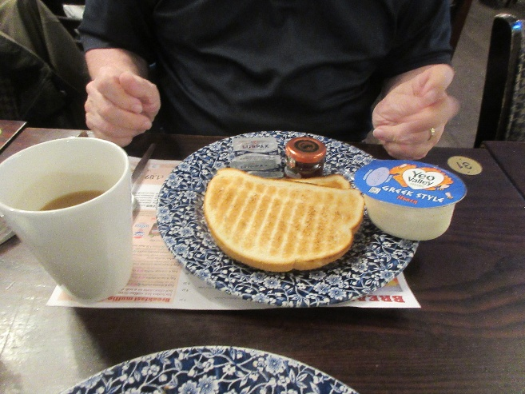
We went back to The Moon Under Water for breakfast. This time scanning the QR code led only to error messages, so I ordered at the bar. I had tea and the "freedom breakfast"—fried eggs, British-style bacon, hash brown cakes, grilled mushrooms, grilled tomatoes, and baked beans. Yesterday's fried egg was perfect. These were a little leathery on top from sitting under a heat lamp. David ordered a honey-flavored yogurt, tea, and toast.

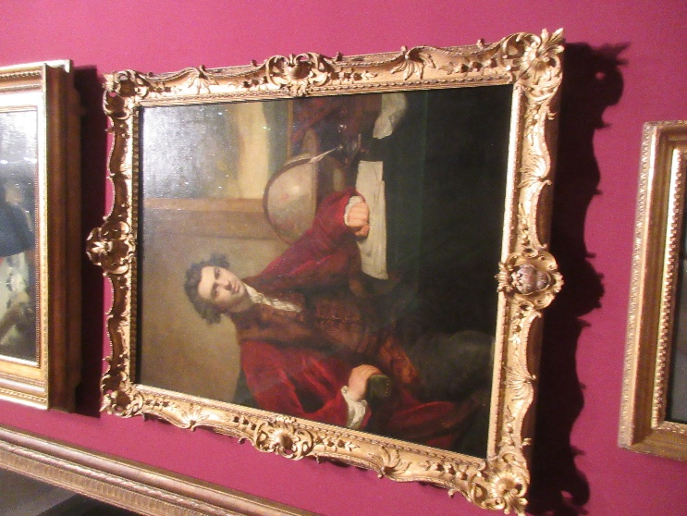
Then it was back to the NPG to polish off the third floor and cover most of the second. Among the hundreds of notables, I found Thomas Bewick (by James Ramsey), for whom Bewick's wren is named; Capability Brown (by Nathaniel Dance), legendary gardener and landscape designer; and Sir Joseph Banks (by Joshua Reynolds), the botanist who sailed with Captain Cook and for whom the genus Banksia is named. (He collected so many specimens at one location that Cook named it Botany Bay.) Banks is pictured here.

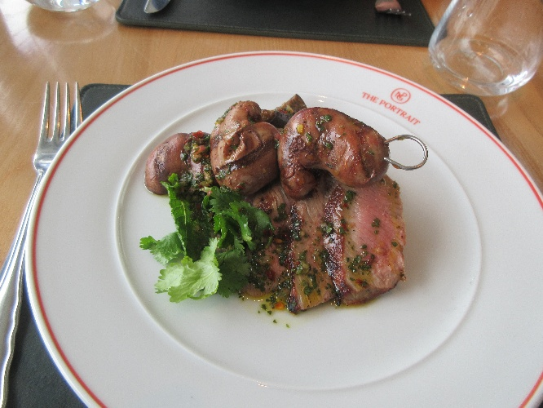
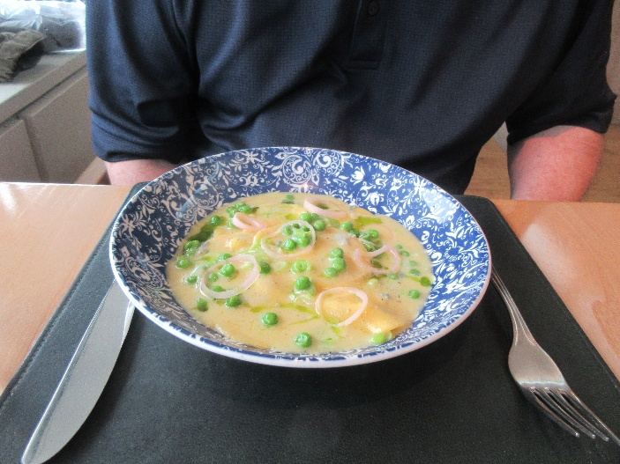
Part way along, we went back to The Portrait for lunch. Here are David's lemon and ricotta ravioli with green peas, Oxford blue, and pickled shallots (he's always been a sucker for ravioli). And my lamb canon with grilled kidney, baba ganoush, chimichurry, a braised eggplant wedge, cilantro, and mint (and none of this nonsense about "how do you want it cooked"; the chef knows his business and delivered both the meat and the kidneys cooked rare, to perfection). Both dishes were outstanding! For dessert, we of course split another Knickerbocker glory.

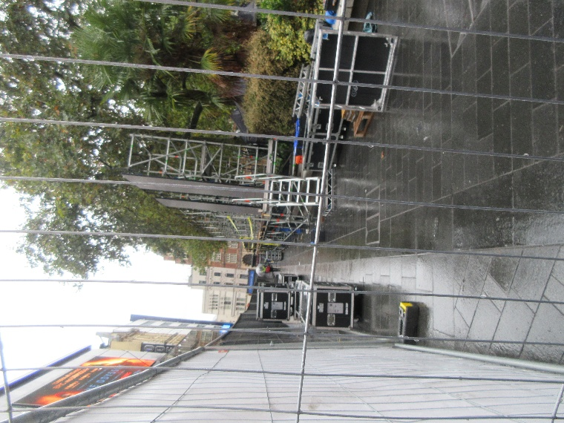
When our feet gave out, we went back to the hotel. The crew preparing for the premier has completely reconfigured their set-up, moving all those tons of equipment (and the sheltering tents) and heaps of scaffolding to the side of the square in front of the Odeon. In this view, I'm facing south, along one side of the square. The façade of the Odeon is to the right, outside the fence.

I finally asked one of the guards what was being premiered. Turns out it's a TV series, Mobland, presumably the start of the second season. It's scheduled for Thursday, so we'll miss it, as we leave that morning for Paris. I've never seen the show, but I would recognize lots of the people in it. Tom Hardy, Helen Mirren, Pierce Brosnan, and others are supposed to be in attendance for the festivities.

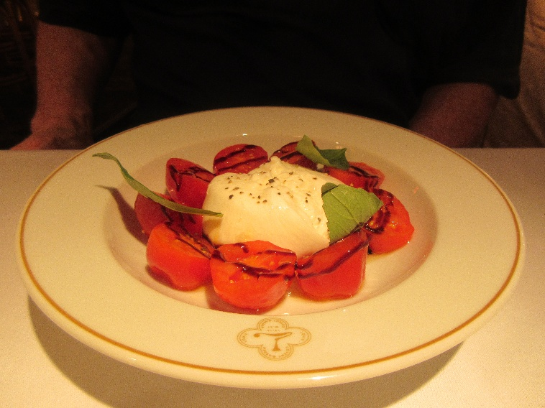
We had dinner reservations at House of Louie (horrible name for a French restaurant!), next door to the Original Ivy.

We ordered from the pretheater menu.

Here's David's starter: heirloom tomatoes, burrata, basil, and a drizzle of balsamic reduction.

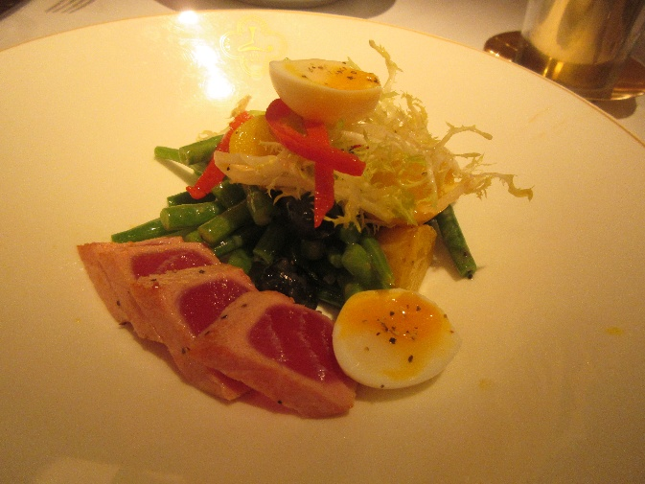
I started with the seared tuna salad, which featured crispy (read "essentially raw") green beans, frisée lettuce, and a soft-cooked quail's egg.

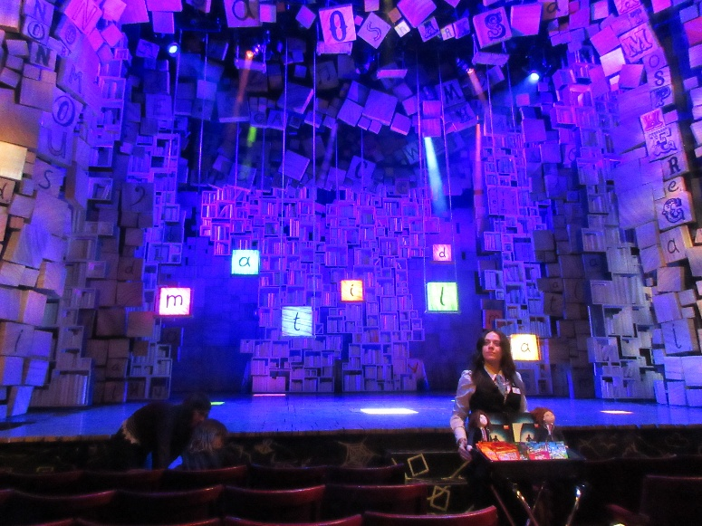
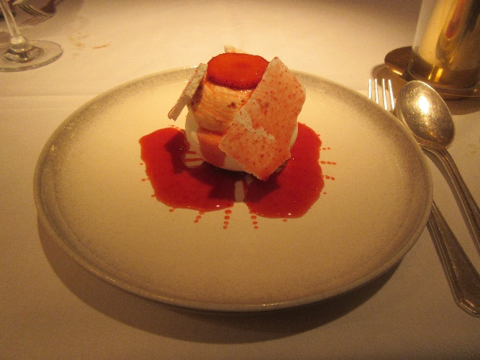
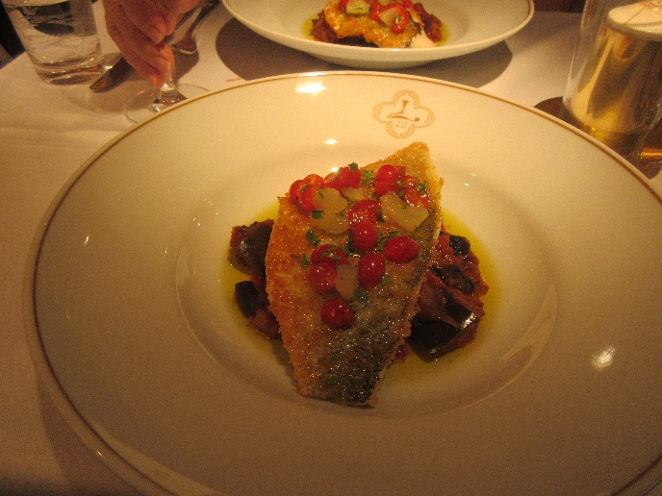
Then we ordered the same main course and the same dessert: crispy sea bream Provençal (i.e., on a bed of tomatoey braised eggplant) with bits of lemon flesh and "tomberries" (exceptionally small cherry tomatoes), followed by strawberry Pavlova.

The evening's show was Mathilda, at the Cambridge Theatre.

At all the other theaters, the vendors in the aisles sold programs, souvenirs, and ice cream. Here it was programs, souvenirs, and all candy (lots of kids were in attendance).

